**SIEBEL KT**

# **Environment Details**

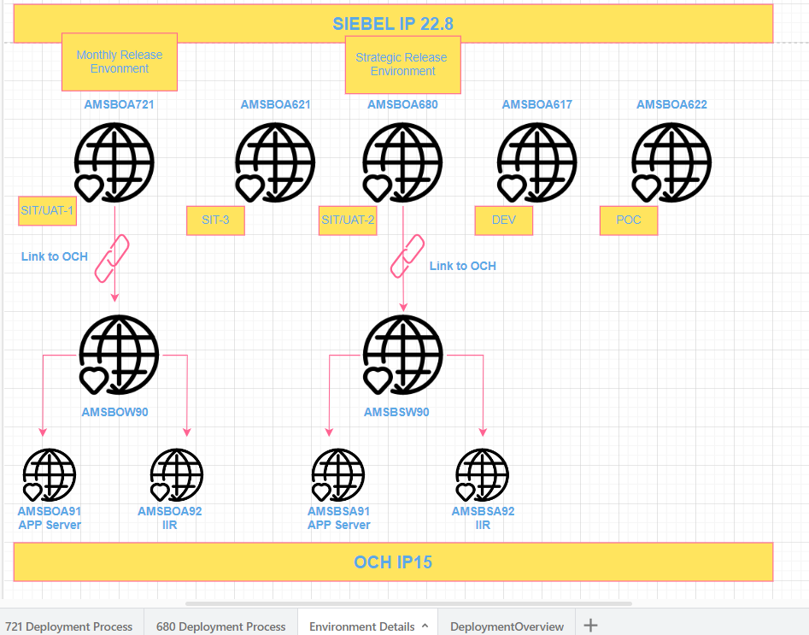

# **Environment URLs.**

|  |  |  |
| --- | --- | --- |
| **DEV URL** | [https://amsboa617:9001/siebel/app/ecommunications/enu](https://amsboa618:9001/siebel/app/ecommunications/enu) | LDAP enabled |
| **DEV URL1 (SDWAN)** | [https://amsboa617:9001/siebel/app/ecomm/enu](https://amsboa618:9001/siebel/app/ecomm/enu) | LDAP enabled |
| **DEV URL2 (Unity)** | [https://amsboa617:9001/siebel/app/ecommun/enu](https://amsboa618:9001/siebel/app/ecommun/enu) | LDAP enabled |
| **Web Tools** | <https://amsboa617:9001/siebel/app/webtools/enu> | LDAP enabled |
| **POC** | [https://amsboa622:9001/siebel/ app/ecommunications/enu](https://amsboa622:9001/siebel/app/webtools/enu) | LDAP enabled |
| **SIT/UAT-2** | <https://amsboa680:9001/siebel/app/ecommunications/enu> | LDAP enabled |
| **SIT/UAT -1** | <https://amsboa721:9001/siebel/app/ecommunications/enu> | LDAP enabled |
| **SIT/UAT-3** | <https://amsboa621:9001/siebel/app/ecommunications/enu> | LDAP enabled |
| **AMSBSW90 (OCH)** | <http://amsbsw90:7781/en/> | LDAP enabled |
| **AMSBOW90 (OCH)** | <http://amsbow90:7781/en/> | LDAP enabled |
| **RFS (OCH)** | <http://och-rfs:7781/en/> | LDAP enabled |
| **PROD (OCH)** | <http://och:7781/en/> | LDAP enabled |
| **RFS (SSO enabled)** | [https://crmrfs.internal.colt.net/siebel/app/ecommunications/enu](https://eur01.safelinks.protection.outlook.com/?url=https%3A%2F%2Fcrmrfs.internal.colt.net%2Fsiebel%2Fapp%2Fecommunications%2Fenu&data=05%7C01%7CSagar.Raj1%40colt.net%7C6cefc541430e4d93b16c08db5dd1ad50%7Cb859cf7eff8a40bbbd0fda56e6dc0eb8%7C1%7C0%7C638206927621626912%7CUnknown%7CTWFpbGZsb3d8eyJWIjoiMC4wLjAwMDAiLCJQIjoiV2luMzIiLCJBTiI6Ik1haWwiLCJXVCI6Mn0%3D%7C3000%7C%7C%7C&sdata=mh01jIvnEJwffashgK%2B82tzJdb6%2FZ%2Bnt6bTTYGxeK8o%3D&reserved=0) | Windows AD enabled |
| **PROD** | <https://coltcrm:7777/siebel/app/ecommunications/enu> | Windows AD enabled |

# **ITSR raising URLs.**

<https://coltit.service-now.com/sp>

* **Siebel User Account Management** --> For Production Application access.
* **Database User Account Creation** --> For Database Access (Prod and Non-Prod)
* **User Account Management on Unix Server** --> For Unix Server Access

# Workspace delivery

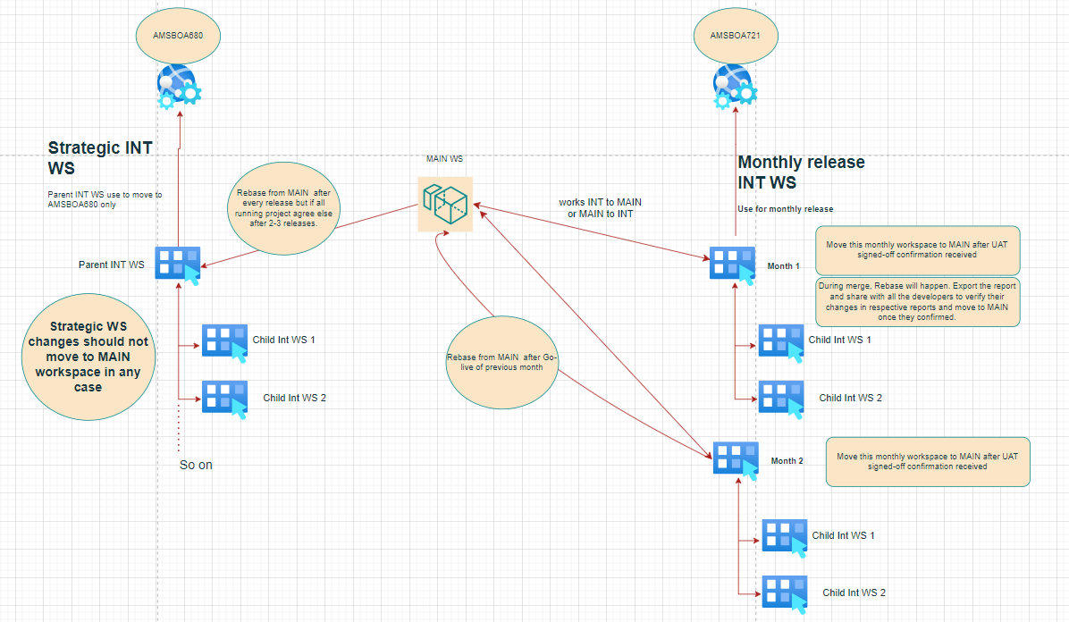

# AOM Components

1. eCommunicationsObjMgr_enu 🡪 Monthly release component
2. eCommunicationsObjMgrHI_enu 🡪 SDWAN
3. eCommObjMgr_enu 🡪 Unity

# Report Extraction

We have 4 types of report which we run every 2nd of month to share with business.

* + Cockpit Report
  + Welcome Email
  + Adoption Report
  + License Report

# Open UI

We received the emails from (Rajesh/Satheesh/Shashi/Pranjal/Mukul/Sunil) for file deployment with all the details.

Below is the path where we deploy the file,

**custom_js**="/u01/app/siebel/AI/applicationcontainer_external/siebelwebroot/scripts/siebel/custom

**spark_r2**="/u01/app/siebel/AI/applicationcontainer_external/siebelwebroot/scripts/siebel/custom/spark-r2/”

**img**="/u01/app/siebel/AI/applicationcontainer_external/siebelwebroot/images/custom"

**css**="/u01/app/siebel/AI/applicationcontainer_external/siebelwebroot/files/custom"

# **Net Cracker**

This is the utility installed in the Siebel servers to connect to NC Interface.

Installation path 🡪 /u01/app/java-utility

Stop script 🡪 /u01/app/java-utility/siebel-comorders/scripts/Stop_NC_JU.ksh

Start script 🡪 /u01/app/java-utility/siebel-comorders/scripts/Start_NC_JU.ksh

Logs 🡪 /u01/app/java-utility/siebel-comorders/scripts/NCJUqueueprocess.log

Xmls 🡪 /u01/app/java-utility/siebel-comorders/input/

# Application Overview

Below we have covered as part of Application overview.

1. Order check
2. Order creation
3. Account level
4. Tickets
5. Service Requests
6. ADM

# Workflow Policies

There are different components for processing different group records. Each component is liable to process only those records which associated under it’s configured group.

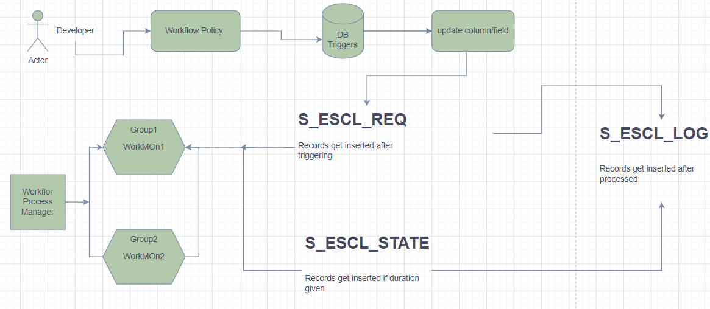

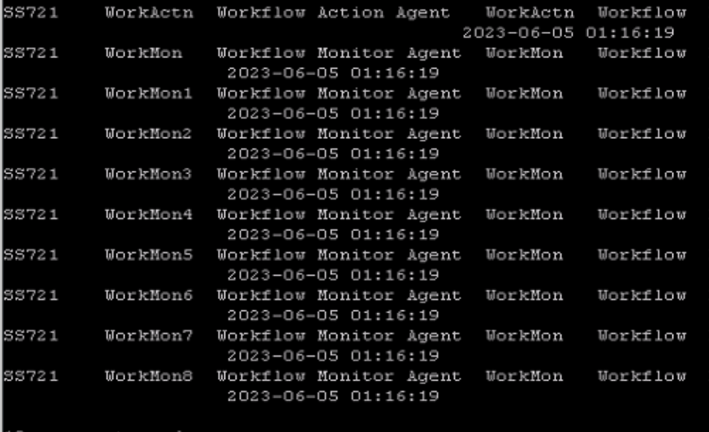

Using below command, we can find which group associated with which component.

**List param %Group% for comp WorkMon**

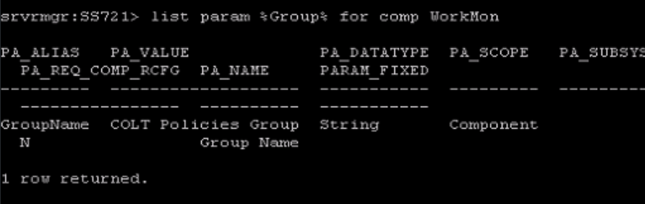

# Workspace Management

We have 2 UAT environments and both are running on different Integration workspaces.

1. Strategic Project changes 🡪 always go to 680 and shouldn’t move to MAIN WS.
2. Monthly Project changes 🡪 always go to 721 and moved to MAIN after UAT sign-off and then to RFS and PROD.

Note –

1. After each release, we need to rebase the same to next release WS.
2. After each release, we need to rebase the Strategic Project INT WS from MAIN (with production changes) after confirmation from project leads.

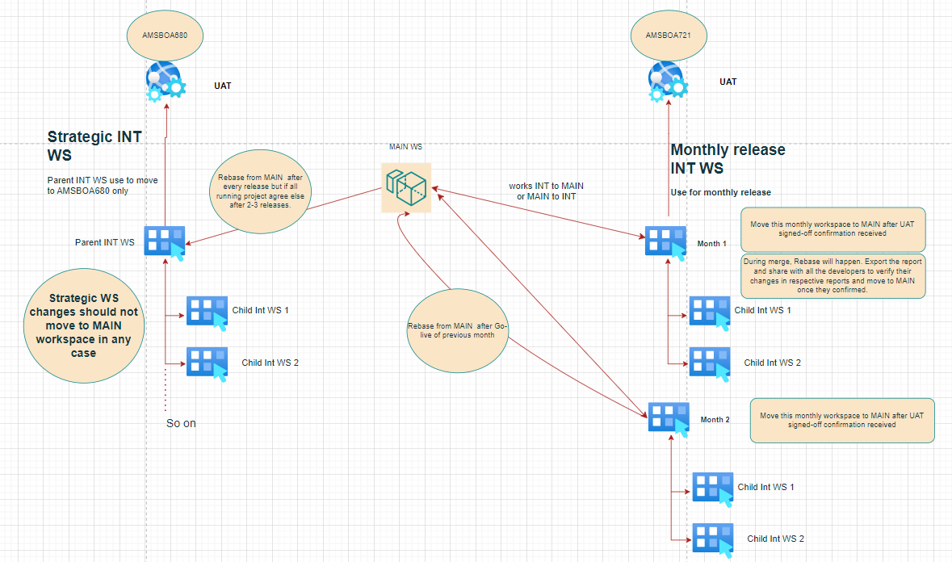

# Server Management

Covered below topics.

1. Crash FDR file
2. FDR to CSV conversion
3. Logs generation
4. Server restart
5. Component restart
6. SMC overview

# Migration Process

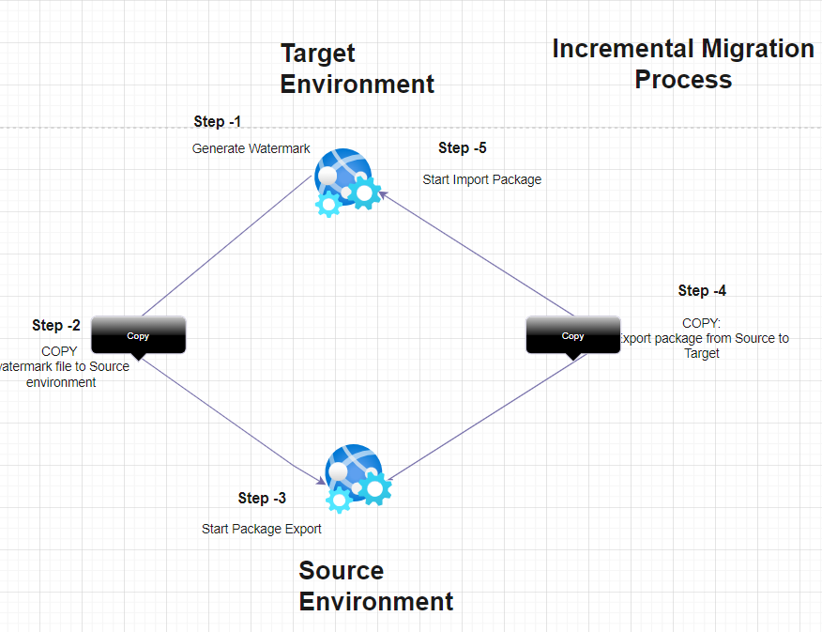

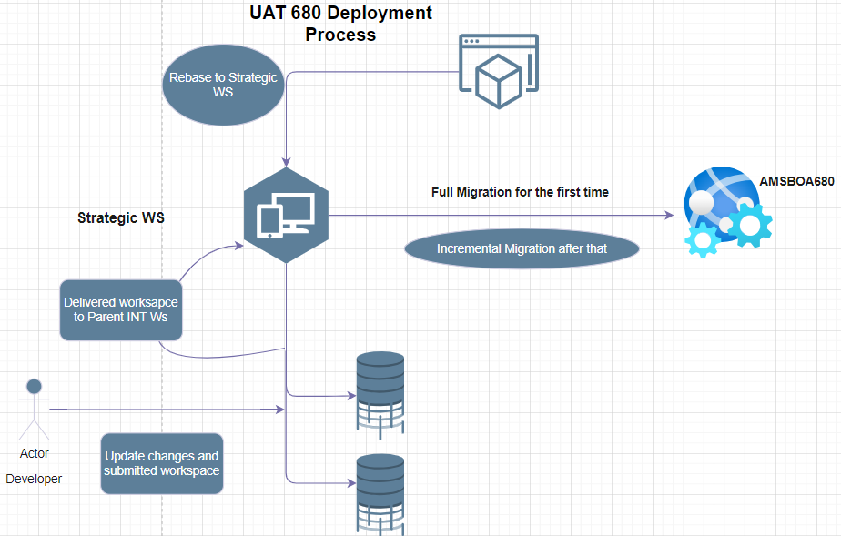

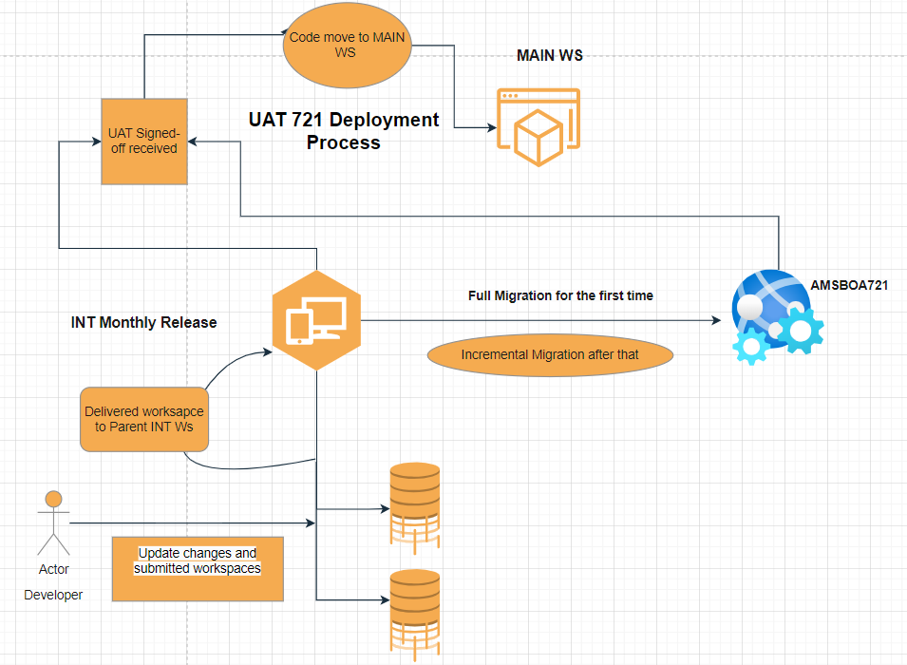

# Data Process

* DB Views/Procedure etc. 🡪 We have to share the DDL with DBA Team in every release for RFS and Production deployment as per Object Tracker.
* Open UI 🡪 We need to share the OUI file to Siebel Production Admin Team to deploy in RFS and Production.

# Sharepoint

Below is the sharepoint URL which we are using here.

[**https://coltinternal.sharepoint.com/SitePages/Home.aspx**](https://coltinternal.sharepoint.com/SitePages/Home.aspx)

# Share Drive

Below drive can be used for any files to share.

**O:\universal\Temporary**